Stem cell research offers hope on type 1 diabetes



Harvard researcher Douglas Melton developed a process that starts with stem cells and results in pancreatic cells that secrete insulin.
When his two children were stricken with type 1 diabetes, Harvard stem cell scientist Douglas Melton says, he did what any father would want to do: He set out to cure the disease.
After 15 years of effort, including some false starts and regulatory hurdles, Melton has taken a major step toward that goal.
In a paper published in the journal Cell on Thursday, he reported a step-by-step procedure that starts with stem cells and results in hundreds of millions of the precious pancreatic cells that secrete the hormone insulin, keeping blood sugar levels in balance. It is the lack of insulin produced by those cells, called beta cells, that lies at the root of type 1 diabetes.
Ultimately, the hope is those cells could be transplanted into diabetes patients and allow them to create insulin naturally, creating a paradigm shift in treating a disease currently kept in check by insulin injections.
Melton cautions that the work is still years from being tested in patients and many challenges, scientific and practical, remain. But he is gratified to have reached this point and even more motivated to continue, so as not to disappoint the millions of people who suffer from type 1 diabetes, which is usually diagnosed in children and young adults.
“We’re tired of curing mice,” Melton said in an interview. “Most patients are sick of hearing that something’s just around the corner; I’m sick of thinking things are just around the corner. But I do believe in the big picture.”
Melton hopes the cells could be ready to be tested in people in a few years. Already, cells are being transplanted into primates through a collaboration with a researcher in Chicago.
Melton’s work is expected to energize the diabetes research community.
Dieter Egli, assistant professor in the pediatrics department at Columbia University Medical Center, said his laboratory will try to repeat Melton’s experiment immediately.
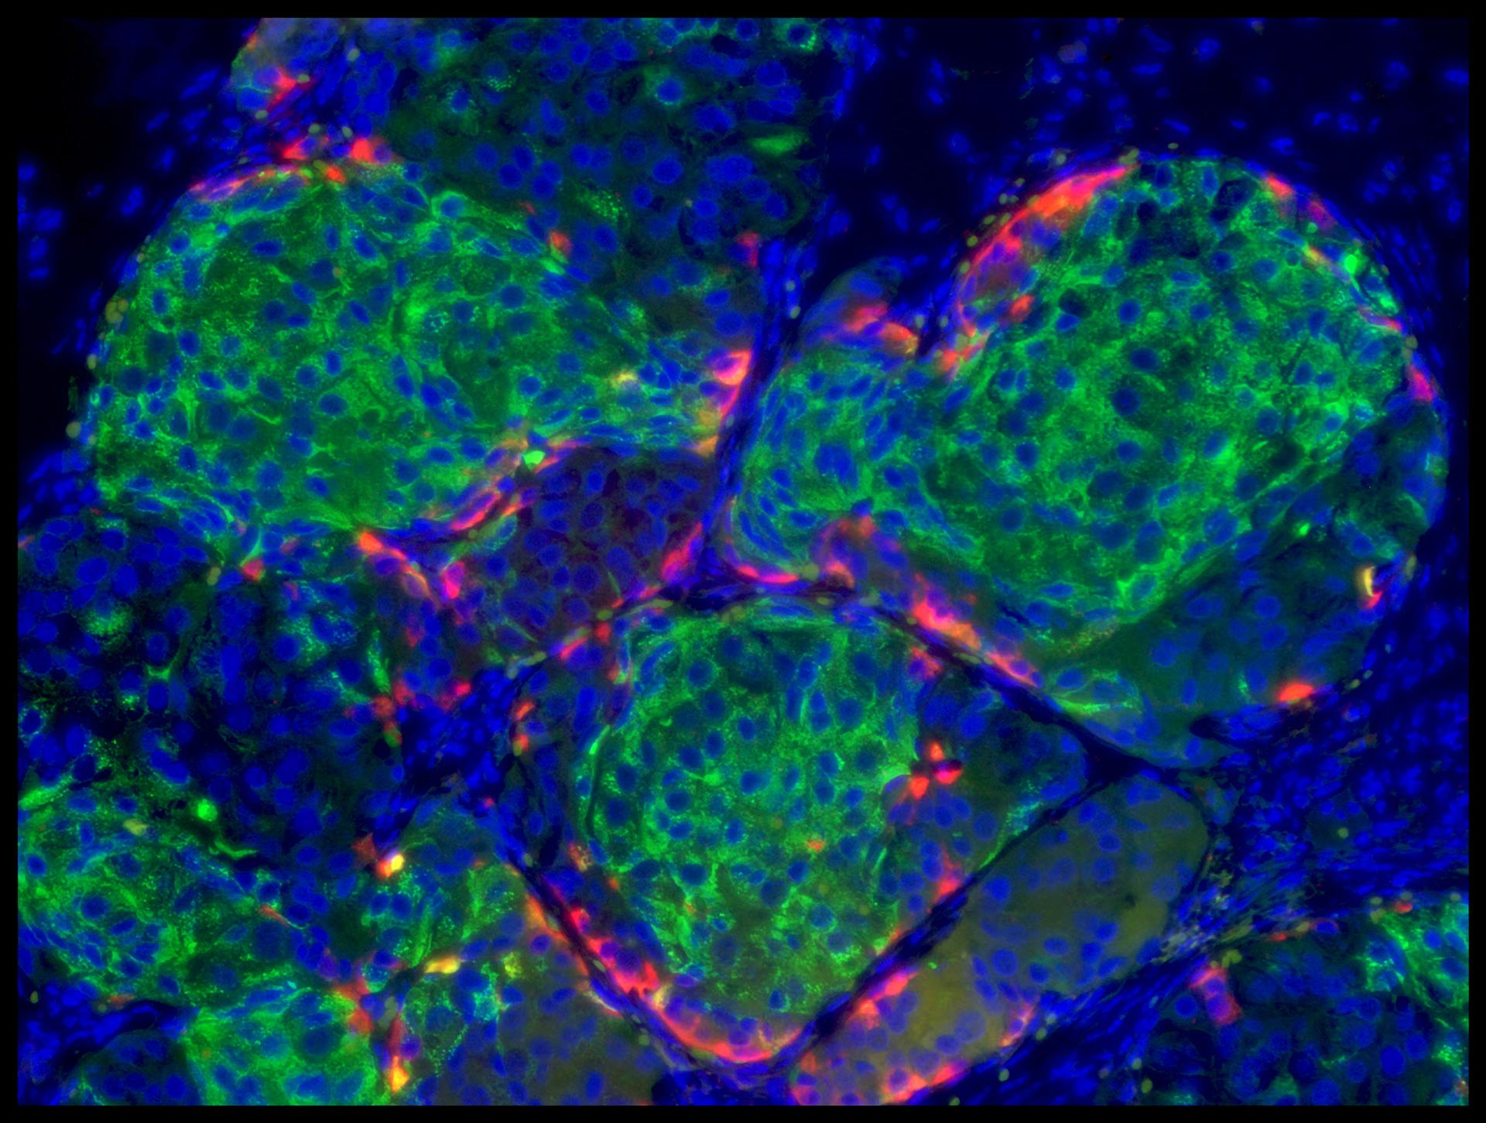

Pancreatic cells that secrete insulin.
“It’s a wonderful result, something we’ve been waiting for quite awhile,” Egli said.
Earlier this year, Egli’s laboratory was able to create embryonic stem cells from a person with type 1 diabetes, through a process called somatic cell nuclear transfer. He now plans to use Melton’s procedure to create the beta cells that are affected by the disease.
Egli said that while he hopes the work will allow him to transplant cells into patients one day, the ability to generate large numbers of beta cells in the laboratory will also aid in the near-term search for diabetes drugs that work on beta cells in diseased patients.
Melton is also collaborating with a researcher at the Massachusetts Institute of Technology to surmount the other major challenge in treating type 1 diabetes: stopping the immune system from attacking and killing the beta cells within the pancreas that secrete insulin. Together with MIT bioengineer Daniel Anderson, he hopes to create an encapsulation technology that could protect the cells from the immune system.
Other attempts to use stem cells for diabetes therapy have been making steady progress. A clinical trial was announced this summer in which researchers will transplant into patients immature cells capable of developing into beta cells.
Melton’s advance succeeded not because of a single eureka moment but through the hard work of a rotating cast of 50 graduate students and postdoctoral researchers in his Cambridge laboratory, who toiled on the project over the last 15 years. The biologists decided the key to making the cells that secrete insulin in the body would be to copy the way they normally develop in the embryo.
First, they carefully tracked the formation of beta cells during development, looking at which genes turned on and off. Then, they tried to emulate the process, triggering those same genes to go on and off using chemicals and growth factors.
The resulting procedure, which Melton compares to the steps of making an involved chocolate raspberry cake, takes about 40 days and involves six steps. The researchers were able to make the insulin-secreting cells from embryonic stem cells and from another type of stem cell, which avoids many of the ethical quandaries of stem-cell research because they are created by reprogramming people’s skin cells into a stem-cell-like state, rather than requiring the destruction of embryos.
The key, Melton said, is that they were able to make the cells in the quantities that would be needed to treat patients — a coffee cup’s worth of beta cells. Now that other researchers have seen that it is possible, he hopes they will take the procedure and improve upon it, making it faster, easier, and more efficient.
Although Melton’s personal motivation is treating type 1 diabetes, the approach also has potential for treating type 2 diabetes, which occurs later in life but can also require patients to use insulin injections.
“I think a lot of people will change how they are harvesting and producing cells in their labs to see if they can reproduce this,” said Dr. Elizabeth Seaquist, president for medicine and science at the American Diabetes Association.
Melton noted that the research would not have been possible without private philanthropy, especially in the years when federal funding for human embryonic stem cell research was restricted under the Bush administration.
“When the Harvard Stem Cell Institute was created in 2004, the university ventured into uncharted and, some thought, untenable terrain,” Harvard president Drew Faust said in a statement. “This accomplishment is something none of us could have predicted 10 years ago, and I am excited to see where it will lead.”

